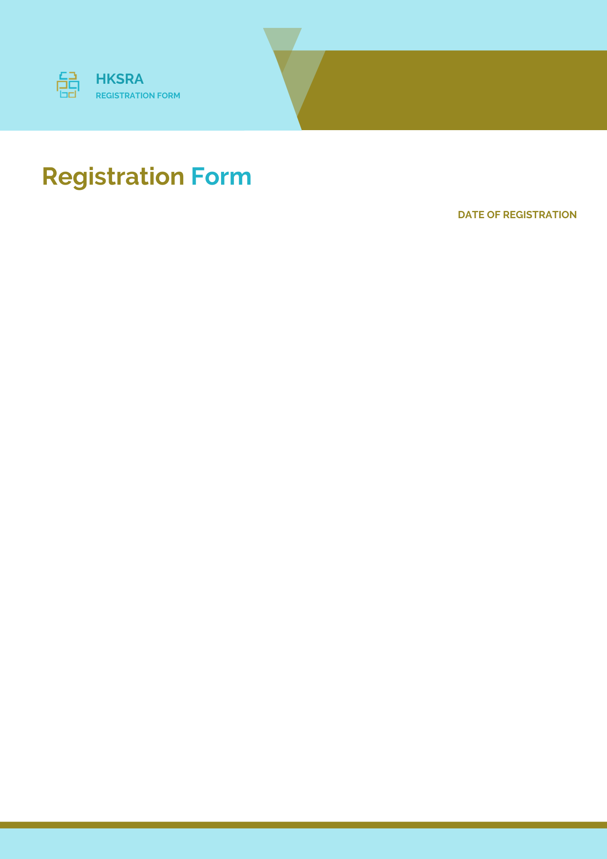
2024 International Conference on Industrial
Automation, Robotics and Control Engineering
(IARCE 2024)

Section 1: Basic Info.
Full name: |  | Affiliation:
Position: |  | Mobile:
Email: |  | Address:
Nationality: |  | Zip Code:
Alternative  Liaison： |  | Mobile:

Section 2: Author Information
Paper ID: |  | Paper Pages: |  |  | Additional Page(s):
Paper Title:
Authors:
Will you attend the conference in person? |  |  |  | Yes No □
Presentation Terms √: |  | Oral □ Poster □  (If you would like to attend the conference online, please contact contact@iarce.org)
Conference meal √: |  | Lunch □ Dinner □
Special requirement √: |  | Diabetic □ Vegetarian □ Halal Food □  Other □ (please specify: )

Section 3: Registration Fee
Category | Early Birds  June 19, 2024 | Regular Registration  June 20-Sept. 19, 2024 | On-site Registration  Sept. 20, 2024 | Your Choice
Full Paper (Regular Author) | 500USD | 550USD | 600USD
Full Paper (Student\Committee) | 450USD | 500USD | 550USD
Full Paper (HKSRA Member) | 470USD | 520USD | 570USD
Abstract (Regular Presenter) | 400USD | 450USD | 500USD
Abstract (Student\Committee Presenter) | 350USD | 400USD | 450USD
Abstract (HKSRA Member Presenter) | 380USD | 430USD | 480USD
Additional Page |  |  | 70USD
Extra Paper Upload |  |  | 300USD
Listener\Co-Author |  |  | 250USD
Extra Conference Proceeding |  |  | 65USD
City Tour\Social Networking Event (Optional) |  |  | TBD
Extra Banquet Ticket |  |  | 50USD
Your Total Conference Fees:
*One regular paper is within 5 pages, including all figures, tables, and references. Extra pages will be charged for Additional Pages Fee.
*All accepted papers will be published on-line.
*Full Conference Registration Includes: Access to meetings sessions on September 20-22; Publication of one full paper; Free coffee breaks, lunch and dinner on September 21; Conference kits.
*For "No shows", registration fee is nonrefundable and the organizing committee shall not be liable for any compensation or refund.
*Cancellation Policy
If a registrant is unable to attend IARCE 2024, they may substitute, by arrangement with the conference organizer, someone else to attend the conference, or transfer their participation to another conference in HKSRA conference portfolio. If the aforementioned solutions are not applicable to the registrant, the following policies of cancellation and refund apply.
- Up to 90 days prior to the conference date:
70% refund of the registration fees paid
- Less than 90 days, but more than 60 days prior to the conference date:
60% refund of the registration fees paid
- Less than 60 days, but more than 30 days prior to the conference date:
50% refund of the registration fees paid
- Less than 30 days prior to the conference date:
No refund
Please note: The cancellation and refund request must be made formally through email to contact@iarce.org.
*Shall the conference is delayed or prevented (directly or indirectly) by the reasons of natural disasters, war, strike(s), epidemic or any other events which could not be controlled, the organizing committee shall be under no liabilities. The organizing committee reserves the right to change the conference date, venue or form of the conference (online or on-site).
PAYMENT INFORMATION
- Please calculate the amount of your registration fee and finish the payment with Online Payment link: http://meeting.yizhifubj.com/web/main.action?meetingId=475
Notice
Please make sure the conference organizer, HKSRA’s logo is always appear on the page until you submit your payment information. Next you will be directed to the payment page.
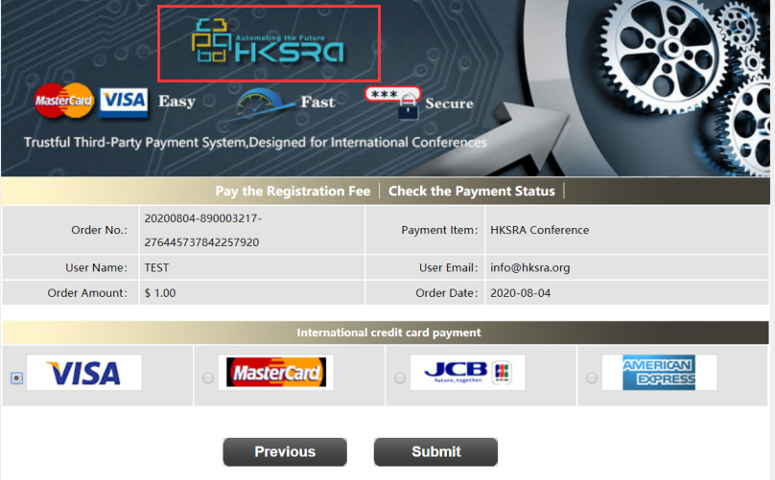
- To pay through PayPal （Please add 4.45% of the total amount to cover handling fees.）
PayPal Account: payment@hksra.org
- Wire Transfer
Please calculate the amount of your registration fee and finish the payment with below bank account: （Please add 30 USD to the total amount of payment to cover bank fees.）
Beneficial name: | Chengdu Forward Information Technology Co., Ltd
The address of  beneficiary: | NO.1513, 15th Floor, Building 1, NO.56 Tianhui  Middle Street, Chengdu High-Tech Zone,  Chengdu, Sichuan, China
Tel: | 86-28-85516109
Account number:  Bank name: | 115875441112  Bank of China Sichuan Branch
Bank address: | NO.35 Section 2 Renmin Zhonglu Chengdu  Sichuan China
SWIFT/BIC (The  Bank's Code): | BKCHCNBJ570

PAYMENT INFORMATION

Please fill in the following blanks after finishing your payment.
Payment Email:
Order No.:
Receipt Issued to:
Student ID No.(student only):
HKSRA Member No. (Member only):

Section 4: HKSRA Member
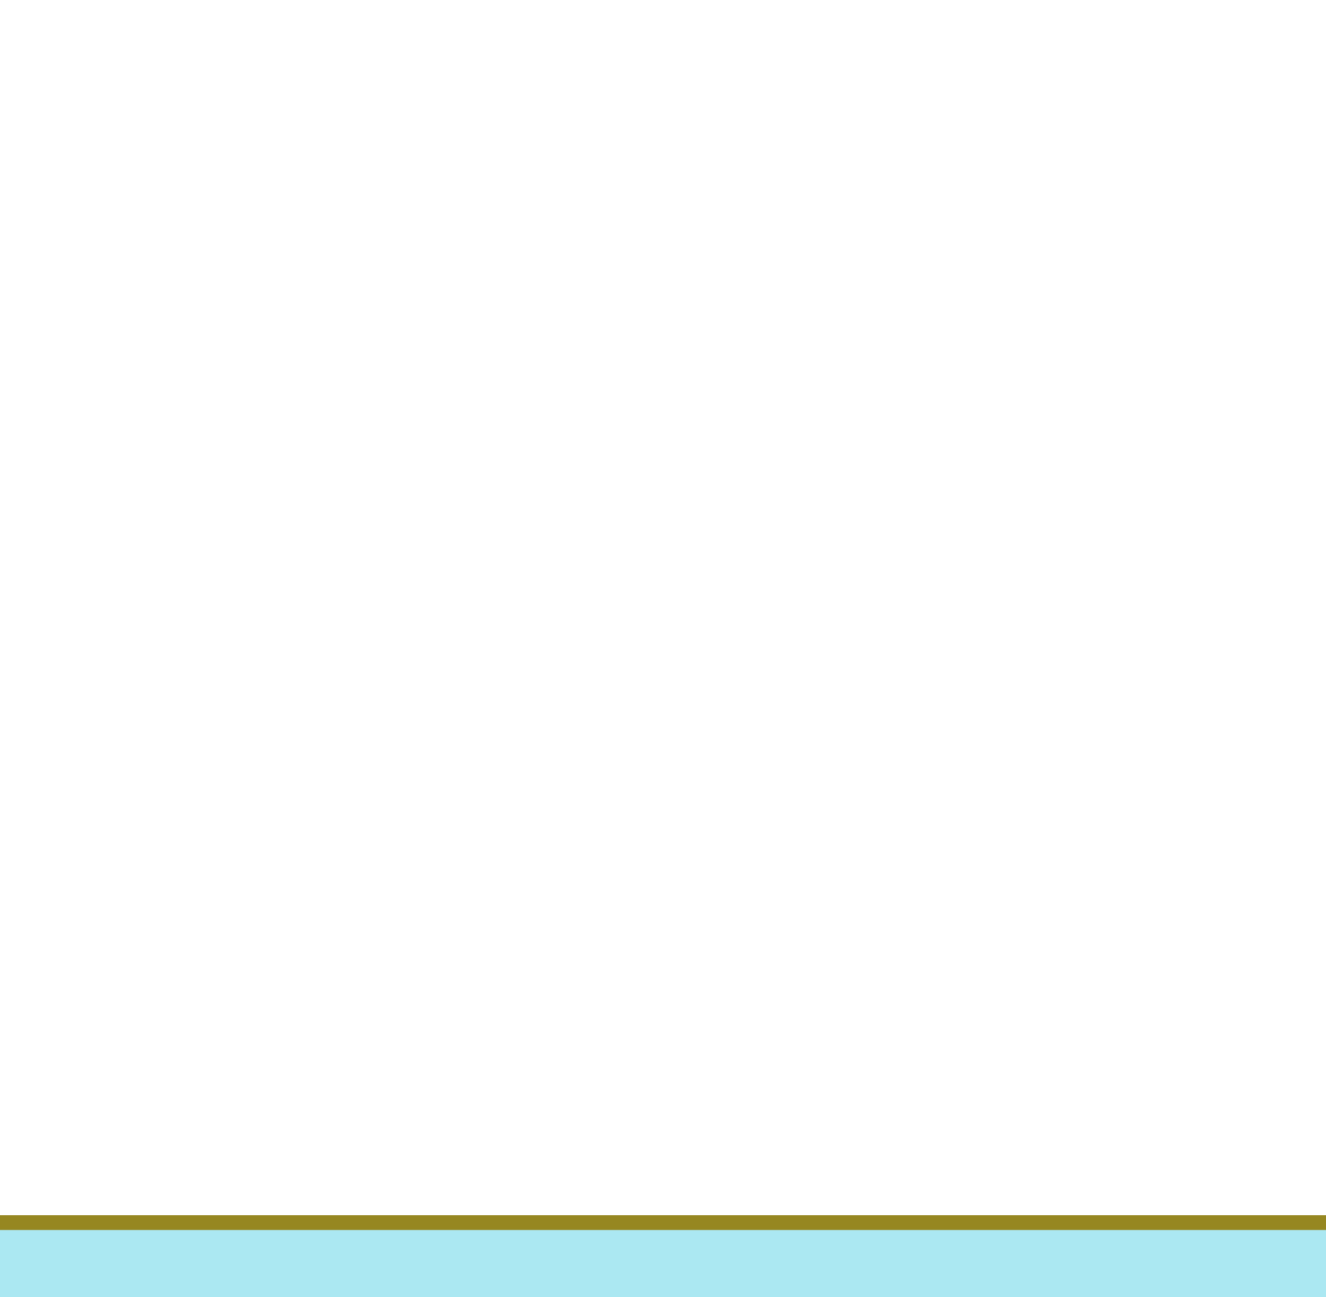
HKSRA MEMBER APPLICATION: Join HKSRA now to qualify for member registration rates.
Please compile and return the Membership Form along with your CV to membership@hksra.org. Your application will be processed in 5 working days.

Section 5: Other
Please provide your one-inch photo for conference use.  BIOGRAPHY:  You are encouraged to write down a biographical sketch here, for  the use of making introductions by Session Chair before your presentation.  20-120 Words(1-6.5 lines)  ng | 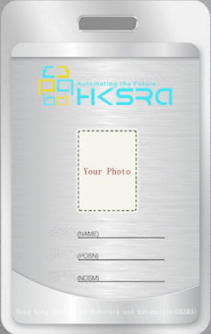
Contact us through HKSRA LinkedIn for the latest news.
HKSRA LinkedIn

IARCE 2024 Organizing Committee
Chengdu

